
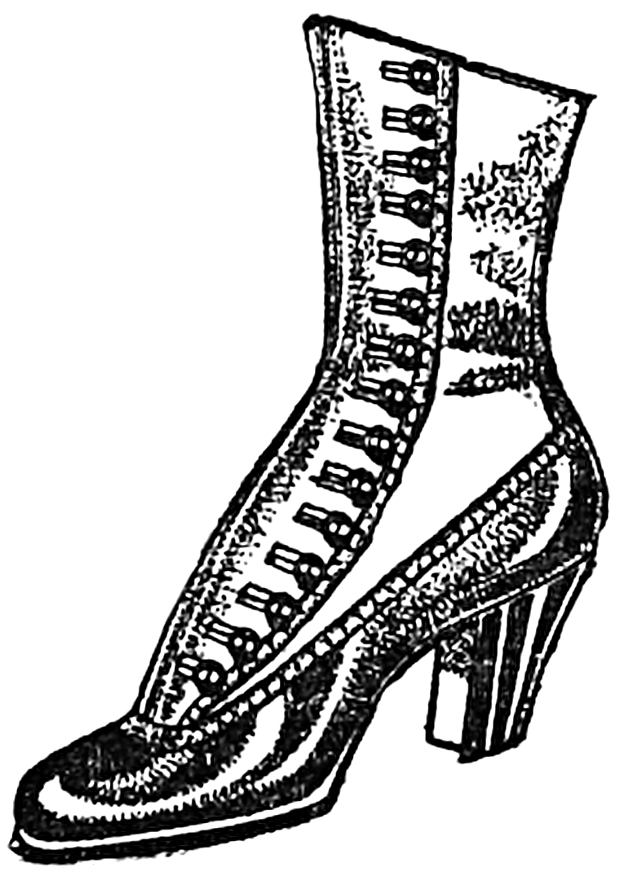

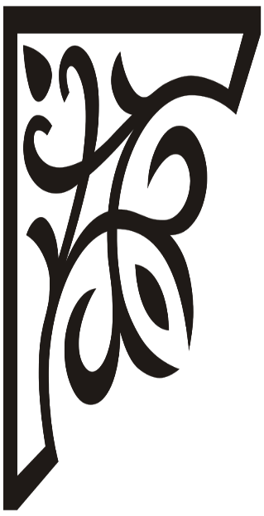

For the everyday Victorian woman! We never sacrifice comfort for fashion, and that we guarantee! Rest assured, our shoes will last you a lifetime. We stand by our name, and our footwear will and always be ‘fit for a Queen’.
Queen Quality Shoes
Made in Boston

This Photo by Unknown Author is licensed under CC BY-SA

